

**Project Title:** Joint 3D Shape Matching

**Student(s): ----------------------------------------------------------------**

**Instructor(s):** Yi Fang (yfang@nyu.edu),

**1. Statement of Project Summary**

Traditional 3D shape matching methods are mainly used on a pair of shapes, both for rigid models and flexible models. With the recent advances in data-driven 3D shape matching technologies, it is natural and feasible to employ the multiple shape information during matching. The goal of this project is to design and implement a multiple shape matching system that takes multiple shape information into consideration, thus provides better results in shape matching. The implementation of the system will benefit model structure analysis and synthesizing. The Surface Correspondence Benchmark provides applicable data for algorithm design and experimental verification.

**2. Background and Review of Literature**

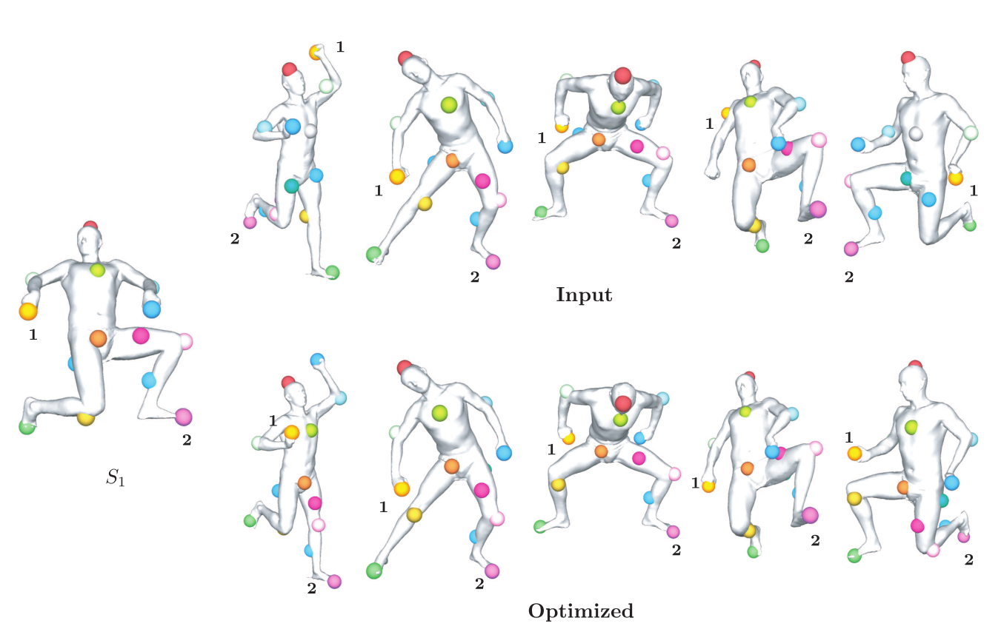

Figure 1 Illustration of multiple shape matching. Input shape matching results are optimized to better matchings.

Finding feature correspondences between two shapes is a fundamental problem in computer vision with various applications such as structure from motion, shape registration, shape analysis, to name a few. If the correspondences between surfaces are known, we can align 3D scans, morph two shapes, establish statistical models and transfer various types of information —such as textures, segmentations and even deformations—from one surface to another.

While previous efforts were mostly focused on matching a pair of images, many tasks actually require to find correspondences across multiple shapes. Recently, there has been growing interest in jointly matching many shapes [1,2,3], via approaches which aim at aggregating information from multiple shapes to improve the maps computed between pairs of shapes in isolation. The most important constraint for joint matching is the cycle consistency, i.e., the composition of matches along a loop of images should be identity. Given pairwise matches, one can possibly identify true or false matches by checking the consistency of cycles in the shape collection. The results can be improved by employing the consistent cycles. Given shape matching results from many pairs of shapes, this system can return an improved matching results using the cycle consistency.

**3. Project Estimated Timetable**

|  |  |  |
| --- | --- | --- |
| ***Estimated Date*** | ***Task Description*** | ***Deliverable*** |
| 18-Nov-15 | Project starts | Project proposal |
| 25-Nov-15 | Background and project readings | Summary of literature |
| 27-Nov-15 | Detailed project requirements document | Requirements document |
| 1-Dec-15 | Proposed solution and design | Design document |
| 7-Dec-15 | Implementation of the proposed solution | Implementation code |
| 14-Dec-15 | Performance evaluation and testing | Evaluation report |
| 21-Dec-15 | Project presentation | Presentation material |
| 25-Dec-15 | Project ends | Final report |

**4. Resources Information**This project requires the following resources:

1. A project workspace for one computer in a lab environment.
2. One computer desktop for the software development

**References**

[1] Huang, Qi‐Xing, and Leonidas Guibas. "Consistent shape maps via semidefinite programming." *Computer Graphics Forum*. Vol. 32. No. 5. Blackwell Publishing Ltd, 2013.

[2] Zhou, Xiaowei, Menglong Zhu, and Kostas Daniilidis. "Multi-Image Matching via Fast Alternating Minimization." *arXiv preprint arXiv:1505.04845* (2015).

[3] Nguyen, Andy, et al. "An optimization approach to improving collections of shape maps." *Computer Graphics Forum*. Vol. 30. No. 5. Blackwell Publishing Ltd, 2011.